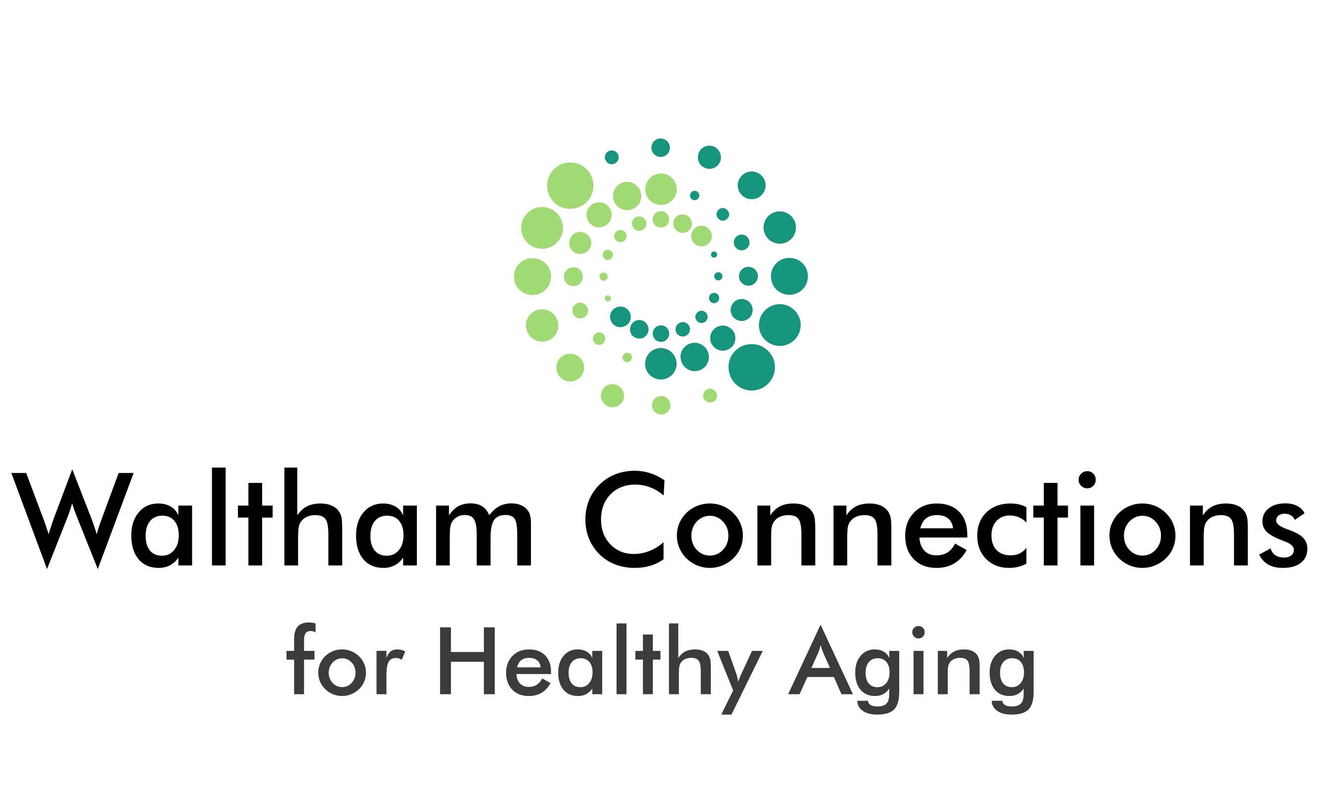

Report on Welcome to the Digital Age (WDA) Refresher Course Interviews
Waltham Connections for Healthy Aging
July 2023

Overview

Since early 2021 Waltham Connections has offered a free Chromebook computer, internet connection, and training to use both to Waltham older adults who cannot not afford them. The program is called Welcome to the Digital Age (WDA) and has been offered in collaboration with Tech Goes Home and with support from grants from McLean Hospital, Springwell, and Tufts Health Plan Foundation. Fifty-five Waltham seniors have graduated in four offerings of the class between spring 2021 and fall 2022. In early 2023 the WDA team decided to offer a “refresher” course to past graduates.

Of the 27 graduates who were reached for the refresher course, 24 said they would like to take it (One said No and two said Maybe). Ten started the five-session (10 hour) class in March, and another 10 took the course in May-June. Most of the refresher participants were from the first WDA class, which presented significant challenges for instructors and students, since initial instruction was on zoom – before many of the students had learned to use their computers, including most importantly being able to access the internet and sign into zoom. Toward the middle of the course, in-person workarounds were developed (instructors’ going to students’ homes, a small class in a common room at a senior housing site), but the class ended before some of the students were competent.

This report is based on qualitative interviews with 8 of the first-round participants. Getting only 8 was a function of low attendance on the days of the interviews and also a couple who did not want to be interviewed. The largely open-ended interview tool (attached) asked about participants’ use of their Chromebooks prior to the refresher class, their expectations for the refresher course, whether the course was meeting their expectations, whether WDA had changed their relationship with the Waltham senior center, and best things and final thoughts about the class so far.

Throughout the WDA classes, about half of the participants have been Spanish speakers. The classes have been conducted in English with simultaneous translation of instruction, printed translation of materials, and individual assistance in Spanish and English. The interviews with Spanish speakers were conducted in Spanish with translation into English question by question.

Findings

The table below summarizes the participants and their answers to some of the top-level questions.

Gender, age, nationality | Use of Chromebook before refresher class | Main goal for the class | Have you learned what you wanted?
Male, 77, El Salvador and Honduras | A lot | Learn zoom | Yes – and using it
Female, 63, Guatemala | A little | Learn applications | Yes
Female, 71, Guatemala | A little | Use it for more things | Yes
Male, 72, Guatemala | A little | Use the internet to do things | Yes and wants to learn more
Female, 65, US | A little | Learn more about computers | Yes – typing, letter writing
Female, 88, US | A little | Learn more and use it more | Use Google, translate to Italian
Female, 65, US | Some | Get more skilled | Yes - Icons, bullets, moving text
Female, 75, Venezuela | A lot | Get more skills | Yes – using colored letters, etc.

Respondent characteristics

Five of the eight respondents were Spanish-speaking immigrants from South and Central America and three were US-born. Six were female and two male. Ages ranged from 63 to 88, with most in their 70’s. Two of the class members on the days of the interviews chose not to be interviewed.

Chromebook use prior to the refresher class and hopes for the class

Two of the respondents was using his Chromebook “a lot” before the refresher class, one was using it “some,” while five were using theirs only “a little.” Clearly it was a good idea to offer the class.

A man who was using his computer “a lot” reported that he had no knowledge of computers before the class and that the class seemed “experimental” (he took the first class in the pandemic.) Nevertheless, he learned enough to be using his computer “for medical things - like find addresses when my doctor sends me to the clinic – where to go for things. I look for news about my countries.” He took the refresher to learn to use zoom.

The woman who was using the computer “some” said: “It’s my companion from when I wake up and I keep it next to me when I sleep.” She took class “to get to know my Chromebook even better.”

At least one of the five using their computers “a little” was affected by the pandemic raging in the first round of classes, e.g., “I was a pandemic student but didn’t learn enough. I tried to practice on my own, but I couldn’t even get to the page where I could choose the applications.” Another simply reported, “I didn’t know how to use it.” Reasons for taking the course among those using their computers “a little” included “I hadn’t learned enough” - “to learn more and use it more” - “to learn how to do my banking and bills.”

Did they learn what they wanted and “best parts”

All 8 responded that they “learned what they wanted.” The third column of the table shows that what they wanted included learning skills, how to use the internet, about their computer, and applications. The last column of the table gives some more specific items. Here are some quotes from the interviews:

Here are quotes from two Spanish-speaking women who learned only a little first round:

- “I want to say how grateful I am for giving me the opportunity to learn. There is no age for learning. We didn’t know where to go to get the knowledge. Now we know. Browsing the Internet, computing, is great for an older person. It is my wish to learn English and with this computer I have found programs to do that.”

- Her favorite part of the class: “There’s a quiz at the end and I want to do well. (Instructor comments: “She does very well.”) I feel good. Because when I was back in my country I didn’t like school. I just got to 4th grade and was punished because of my poor performance. I really enjoy doing well in this class….. Thanks. To the senior center and instructors who helped us so much.”

Here’s one from a native English speaker:

- “I brag to my friends, I can use Google to find information and “go” anywhere in the world and to translate to Italian. I also want to learn how to save info from a thumb drive on my computer. I just got a new TV – it’s a smart TV. I want to learn about apps.”

Relationship to the Senior Center

At the end of the interviews we asked participants whether taking the classes had changed their relationship with the Waltham Senior Center. Nearly everyone said yes and in a positive way.

Here are quotes from three Spanish-speaking seniors:

- “Yes. I found out about services I didn’t know about. Food & nutrition. Transportation to my doctor… I’ve met many people from this organization who have been very kind. I haven’t used all the services yet but I know they’re there.

- She feels “more comfortable…. In 20 years I never knew about this place. Everyone we’ve met here has been very kind.”

- “Yes. At least we know there is hope that there are people who will help us.”

And two English-speaking seniors:

- “It has! I never came for anything. Now I check the newsletter.”

- “YES – I’ve gotten shots here, the senior center van takes me to the doctor. Everyone is so nice. I love coming here and I tell people that. I moved here because I got into housing here in Waltham. I’m not from Waltham and I didn’t know anyone here, but I love it here. Everyone I meet is so kind and friendly.”

Summary

Twenty of 55 seniors who took first-round WDA classes were interested in and took the refresher class. Five of the 8 that we interviewed were using their Chromebooks only “a little” before the refresher, where they hoped to learn more about using their computers, the internet, applications like zoom, how to search for information, shopping, and bill paying. The respondents reported satisfaction in reaching these kinds of goals.

Another benefit of the class was helping these seniors learn more about and feel comfortable in the Waltham senior center. Improving connections with the CoA is especially significant for the Spanish-speaking seniors, who reported in focus groups conducted by Connections in 2015 and 2017 that not having Spanish-speaking staff or materials was a barrier. That barrier has been addressed by Connections initiatives in 2019 to translate the monthly CoA newsletter into Spanish, and the hiring of Spanish outreach workers for the last two years. A Spanish focus group we conducted in 2022 found better CoA connections in the group than in earlier focus groups, showing perhaps the results of outreach efforts. We knew from seeing WDA graduates access other senior center services that the program was helping with outreach. It’s good to hear participants describe it in their own words.

Attachment: Interview questions

WDA Review class series
Interview questions (asked prior to class 4 of 5)
May 2023

Thanks for participating in this brief evaluation of the WDA program. We will use what we learn to improve and promote the program. Please know that we will not use your name in anything we write or say. Your answers are confidential. Is it OK to go ahead?

1. Before these classes, would you say you were using your Chromebook?
a. A lot
b. Some
c. A little
d. Not at all

- If a little or not at all, why?
- If a lot or some, what were you using it for?

2. Why did you want to take this class series?

3. Have you learned what you wanted to learn?

4. Is there anything else you’d like to learn about before this class series ends (2 more classes to go)?

5. What has been the best part about this class series?

6. Has this changed your relationship with the senior center, e.g., do you know more about it? Feel more comfortable?

- Do you have anything else to add?

